

**Demonstration Guide**

**Overview of enStratus**

enStratus helps organizations manage their cloud infrastructure. We provide a unified solution that supports the provisioning, management and automation of applications in all leading public and private clouds, without removing the ability for developers and application operators to choose the configuration management, monitoring and other operation tools that make the most sense for each application.

enStratus provides the following capabilities.

* **Self-provisioning**– end-users can quickly launch and deploy, eliminating wait time and IT backlog
* **Access controls** – easily allocate specific levels of access to development, QA and other teams. Integrate into your LDAP/AD deployment to extend your internal policies into your clouds.
* **Financial controls** – track and limit spending by project code, customer or department
* **Logging and auditing** – track activity by user through reports or by integrating monitoring and management systems
* **API Integration** – leverage your internal management systems by integrating with the enStratus REST-based API
* **Automation** – automate the recovery, backup and scaling of your cloud infrastructure to meet demand and match your service level requirements
* **Configuration Management** – manage complex configuration management requirements with drag/drop ease through the enStratus console
* **Service Catalog** - easily launch templated deployments with automation across hybrid clouds
* **Hybrid Cloud Support** – add any enStratus-supported public or private clouds and continue to manage with one unified solution

**enStratus Introduction**

To most effectively demonstrate how enStratus can benefit an enterprise, follow the following steps:

1. Talk about typical enterprise challenges

* Multiple clouds brings multiple challenges
* Flexibility/elasticity vs. control
* Meeting service level demands
* Extending IT policies and procedures
* Tracking and auditing for compliance

2. Provide a brief overview of what enStratus offers. This can be broken down into three sections:

**Governance** - including role-based security and financial controls

**Automation**- including auto-scaling and auto-recovery

**Independence** – add public clouds and manage with one unified solution

With enStratus, you gain a unified management solution for your cloud infrastructure delivering the security, governance, automation, and controls you need to decrease risk and cost. You can also integrate into internal systems to extend policies and procedures into your cloud.

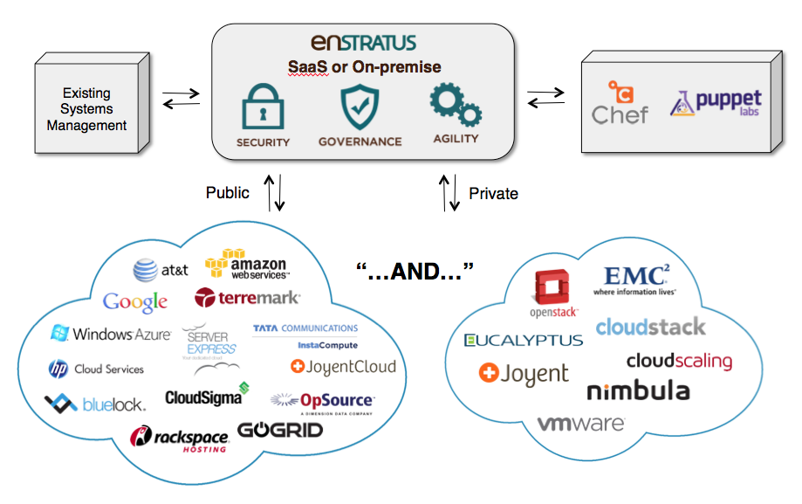

**Demonstration Overview**

To begin demo, log in to the enStratus console

**1.** **Main Navigation:** Once you’ve logged into the enStratus console, show the main navigation bar across the top – briefly scroll across and mention the key functions. This will give the prospect a feel of the various functions of enStratus.



**2.** **Multi-Cloud Support:** Click on the arrow on your enStratus account in the upper right-hand corner to show how you can add new or switch between accounts.

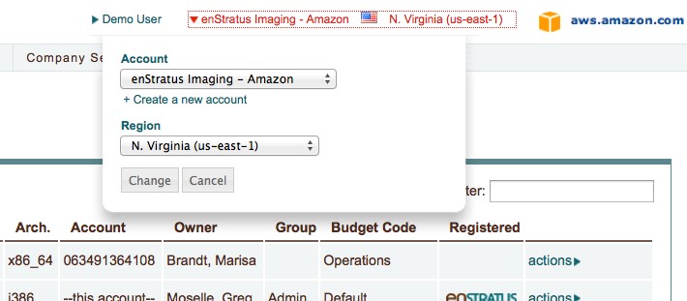

**3. Provisioning:** Click on the Compute Navigation and explain this is where provisioning happens.

Fig 1. Compute Screen

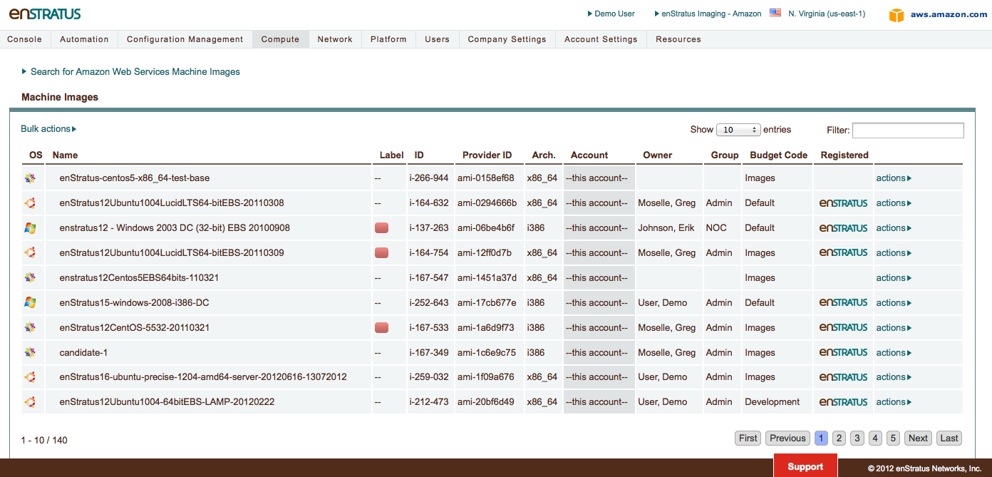

Go to Machine Images in Compute and click on the actions button by a machine image and show the budget codes and other options available.  
  
Fig 2. Launch Screen

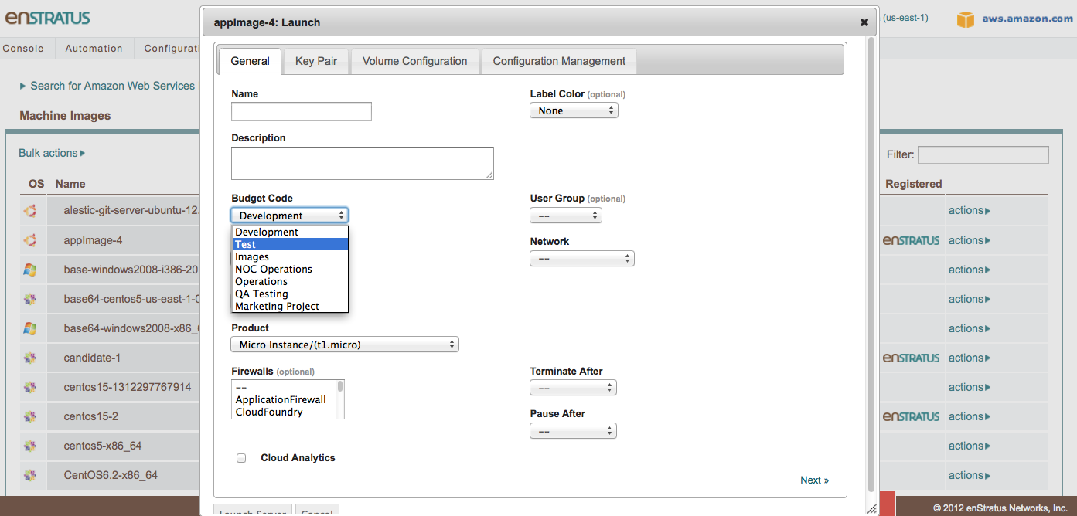

Also show the available information about the running server by navigating to Servers and clicking on actions and then showing Info and/or Logs.

*Optional (if you have integrated with Chef or Puppet) – Show how you can integrate into Chef by launching a machine image and clicking on Configuration Management.*

Fig 3. Configuration Management Screen

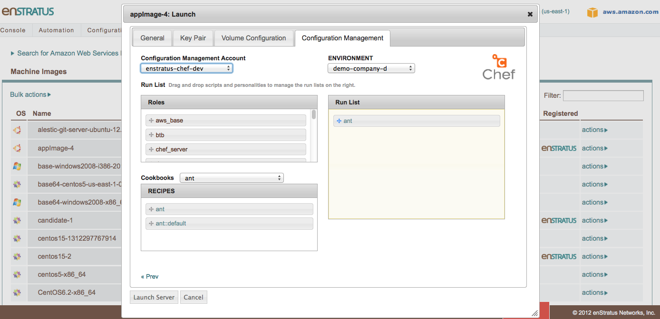

**4.** **Access Rights:** With enStratus, you can provide the right level of access to the right people, across your clouds. This enables you to track and audit your infrastructure. Users are able to self-provision VMs based on their security group.

You can drill down under Users, and select Actions – Access Rights to show how the administrator can set access rights to any resource listed:

Fig 4. Access Rights

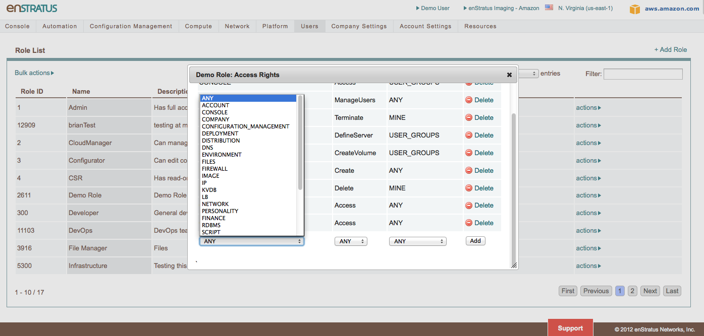

**5.** **Financial Controls:** Drill down under Company Settings to show Budgets – you can assign individuals and groups to specific budget codes. Here’s where you can create a new Billing Code, set soft and hard quotas, and track run rate, current usage, and projected usage as well as deciding what action to take when the hard quota or projected usage is met or exceeded.

* This allows you to limit spending across clouds, and warn your administrator and users when they reach defined limits.
* When a hard cap is met, the user cannot launch new infrastructure using that budget.
* This provides incentive for each user to use resources wisely – if an admin cannot launch another VM because the quota has been exceeded, he may have other instances that can be shut down to open up more budget allocation.

Fig 5. Budget Controls

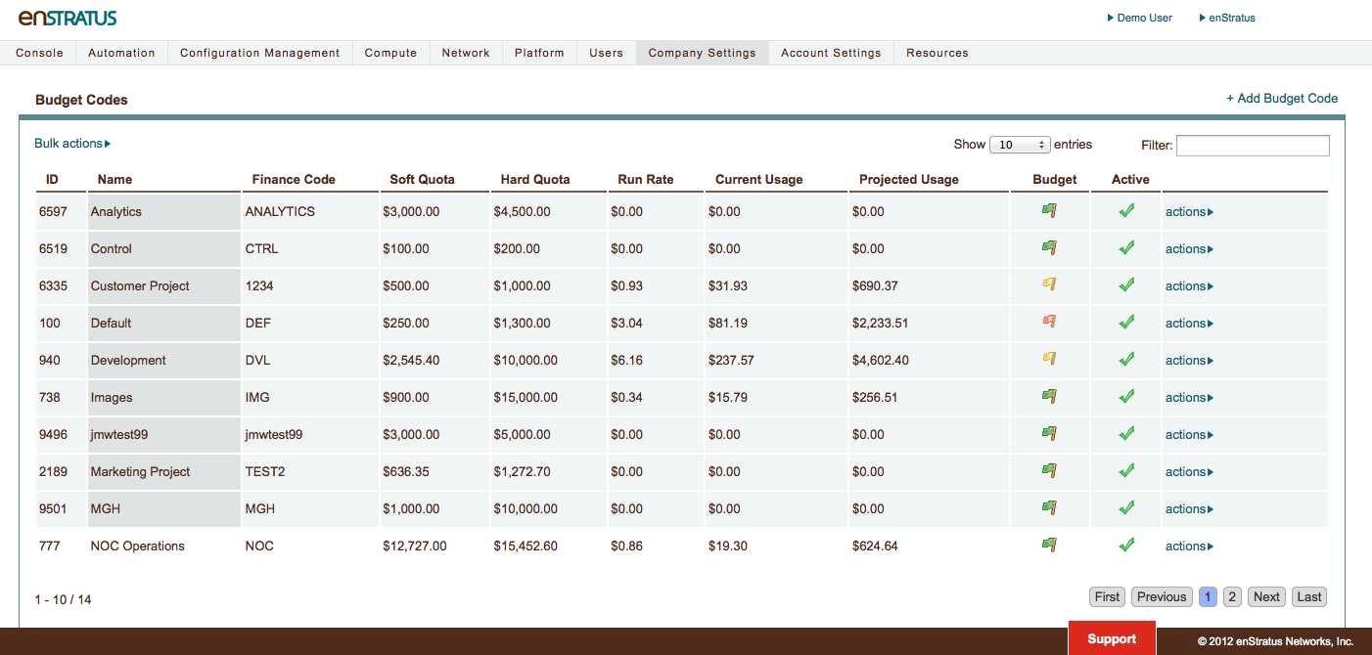

**6.**  **Automation:** Drill down under Automation to show how to setup a deployment and the scaling rules within or across clouds. enStratus allows you to automate deployments within one cloud, or across multiple clouds. Automated scaling, automated backups, automated recovery and cross-cloud bursting help you meet your service levels. Automation triggers can be as simple as CPU utilization or you can use custom triggers unique to your application. enStratus supports leading configuration management tools like Chef and Puppet, as well as containing its own service library.

Fig 6. Automation

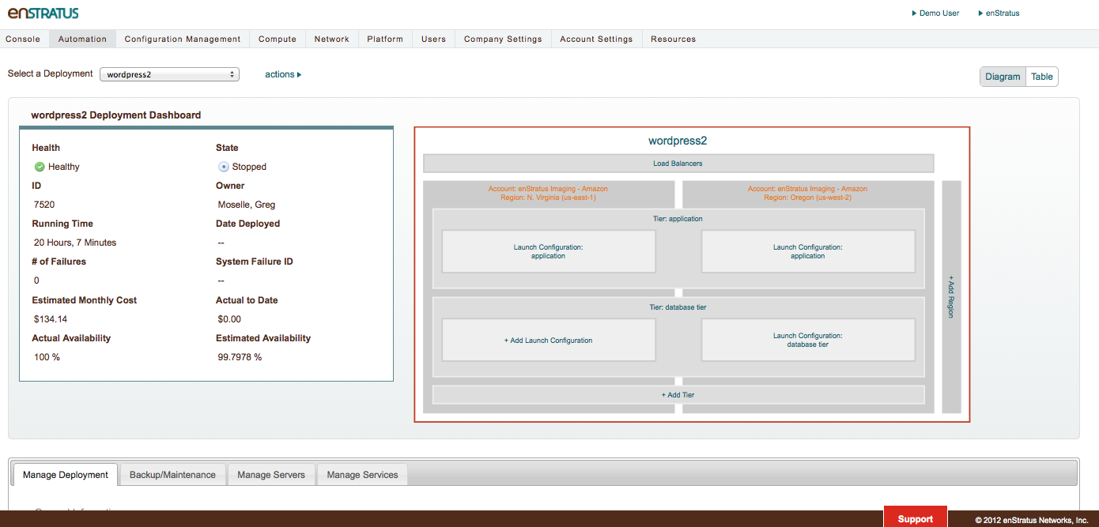

Click on the Application Tier and show the scaling rules. Then click on the Launch Configuration to show the parameters available including Snapshots, and Images.

Finally discuss the Service Catalog where you can publish deployment.

**7. Mention API:**  To leverage your internal systems, you can integrate into Active Directory, LDAP, support systems, billing solutions and more with our REST-based API.

**8. Conclusion:**  Draw the demo to a close. Ask if there are other areas the customer would like to see or drill further down into – if so, a follow-up technical demo can be scheduled with enStratus staff.

**Need More Info?**

Contact:

George Hadjiyanis, VP, Sales & Marketing  
[george.hadjiyanis@enstratus.com](mailto:george.hadjiyanis@enstratus.com)  
+1-612-355-5270